From: https://www.vodafone.co.uk/upgradecbv  
  
To: https://www.vodafone.co.uk/contact-us-b2/index.htm?nuance=offsite&ag=10006377&bu=19001158&cid=vnty-vod-auto/dvynfvtq(uv(bx)bahznyquld

Plive:

https://plive2-www.vodafone.co.uk/contact-us-b2/index.htm?nuance=offsite&ag=10006377&bu=19001158&cid=vnty-vod-auto/dvynfvtq(uv(bx)bahznyquld

Live:

<https://www.vodafone.co.uk/upgradecbv>

https://www.vodafone.co.uk/contact-us-b2/index.htm?nuance=offsite&ag=10006377&bu=19001158&cid=vnty-vod-auto/dvynfvtq(uv(bx)bahznyquld

From:

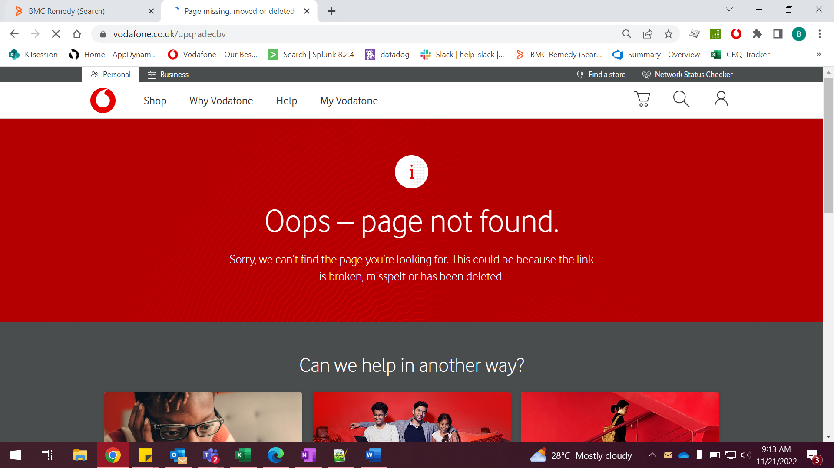

To:

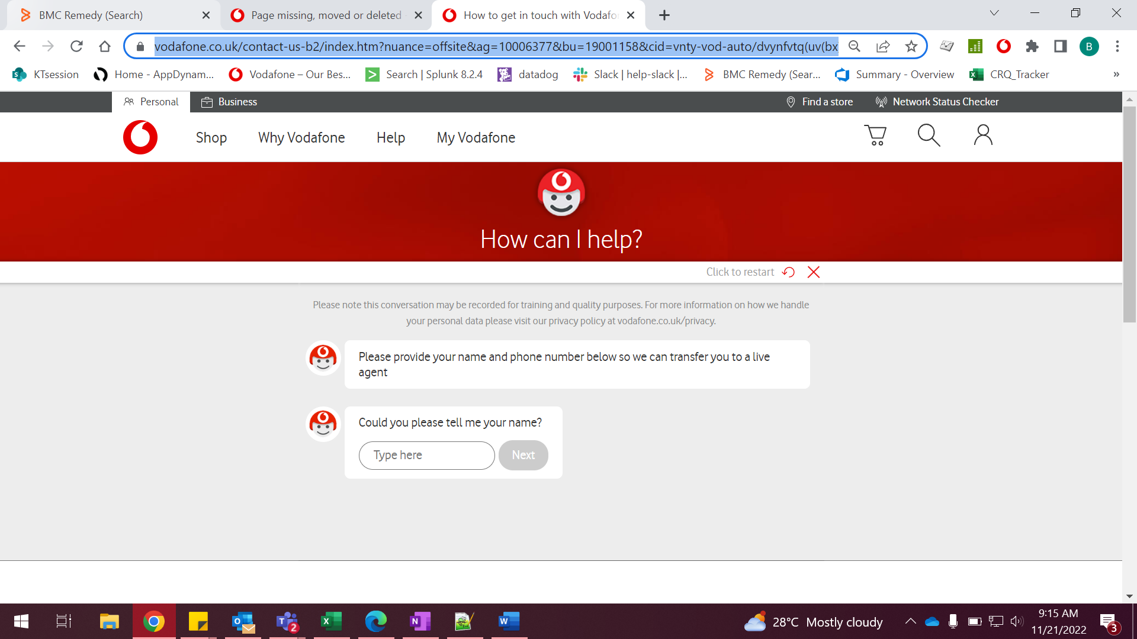

Plive2:

From:

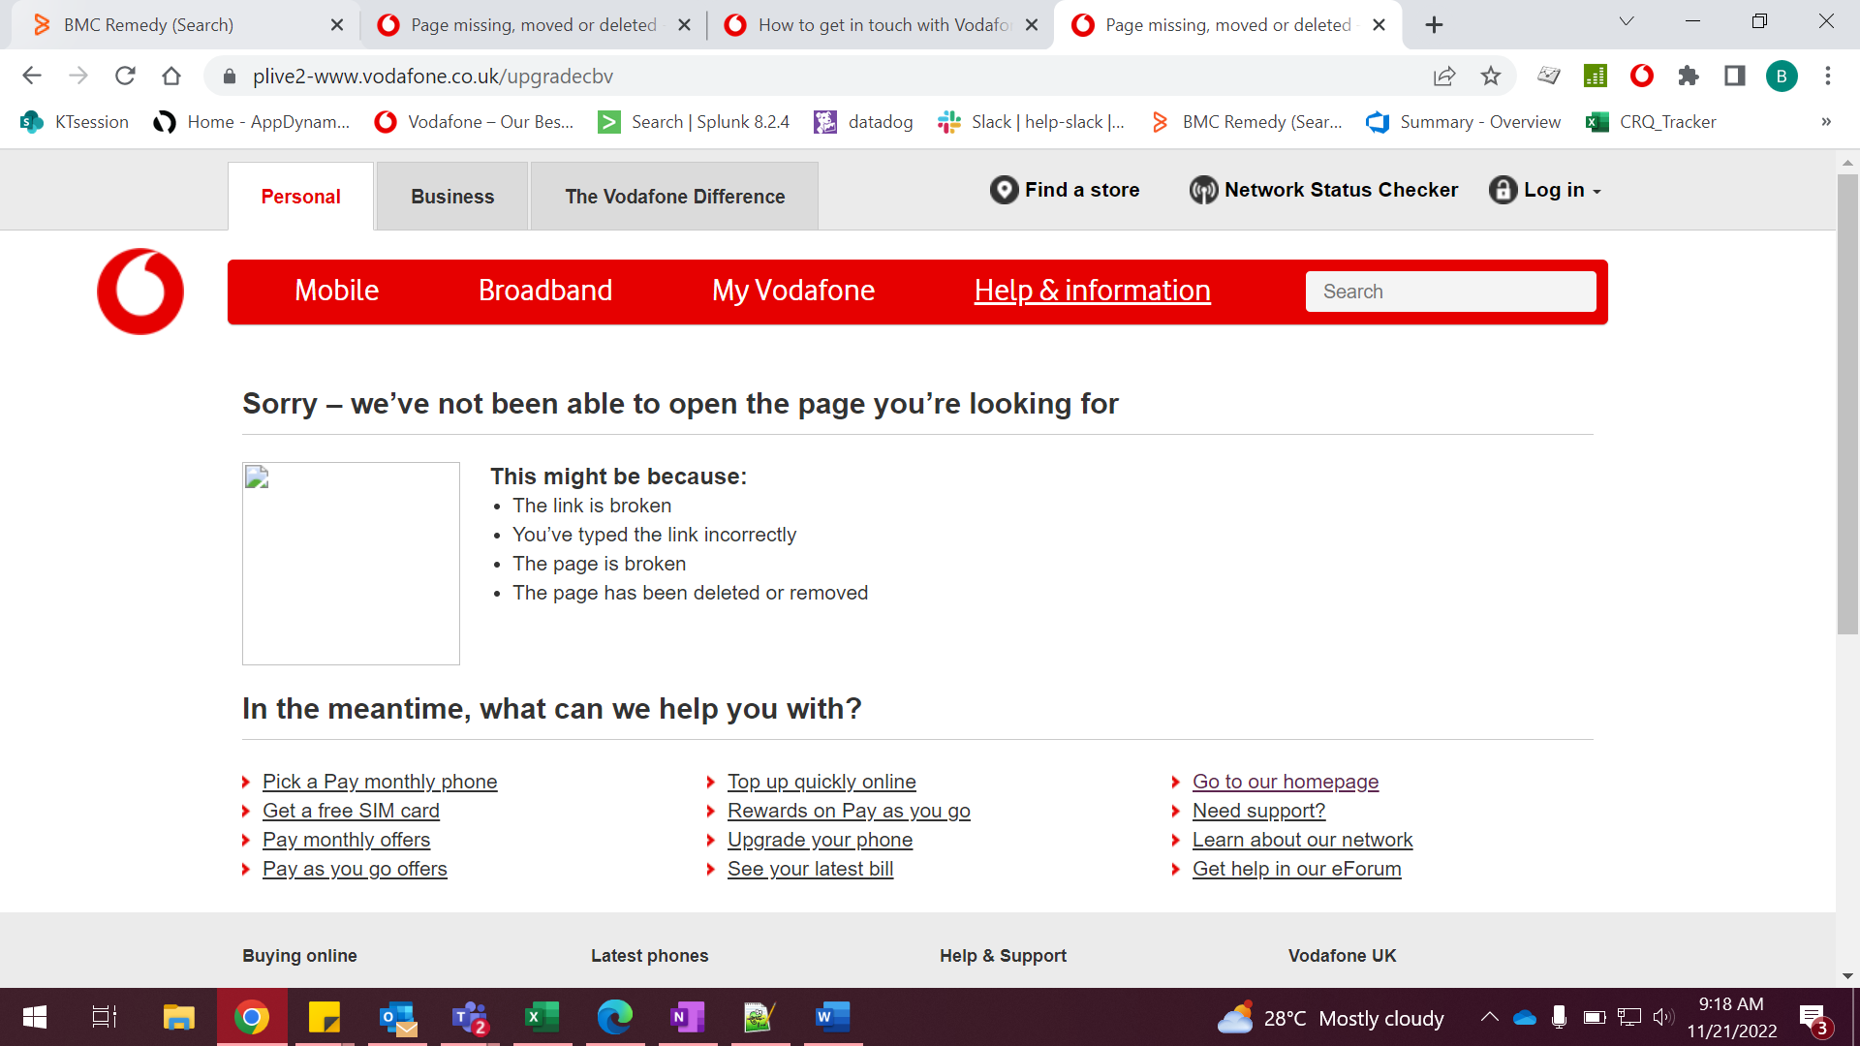

To:

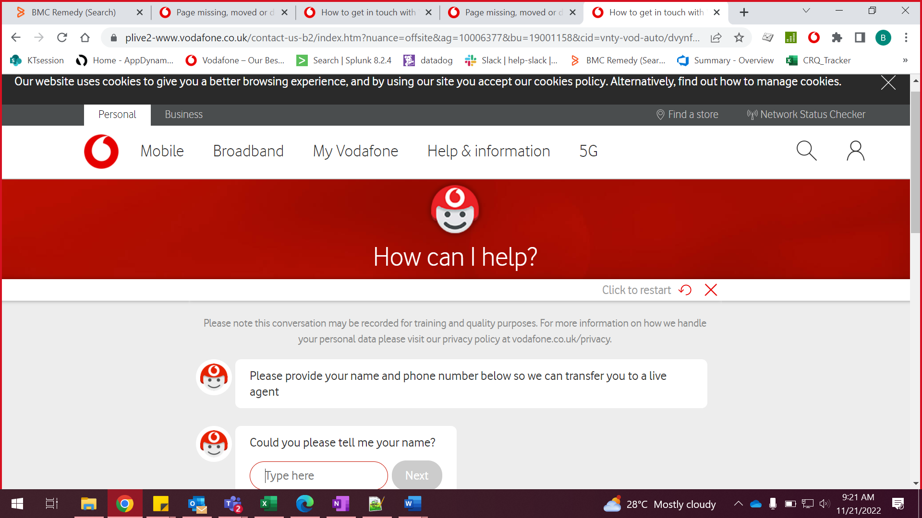

Rule:  
  
Actual:

From: https://www.vodafone.co.uk/upgradecbv  
  
To: https://www.vodafone.co.uk/contact-us-b2/index.htm?nuance=offsite&ag=10006377&bu=19001158&cid=vnty-vod-auto/dvynfvtq(uv(bx)bahznyquld

**"From: https://www.vodafone.co.uk/enquire-returns**

**To: https://www.vodafone.co.uk/contact-us-b2/index.htm?nuance=offsite&ag=10007202&bu=19001158&cid=vnty-vod-auto/dvynfvtq(uv(bx)qtpbjzq[zqobzts"**

**==**

**#**

**RewriteRule ^/** **upgradecbv$ /contact-us-b2/index.htm?nuance=offsite&ag=10006377&bu=19001158&cid=vnty-vod-auto/dvynfvtq(uv(bx)bahznyquld [NC,R=301,L]**

**RewriteRule ^/ upgradecbv/$ /contact-us-b2/index.htm?nuance=offsite&ag=10006377&bu=19001158&cid=vnty-vod-auto/dvynfvtq(uv(bx)bahznyquld [NC,R=301,L]**

**#**

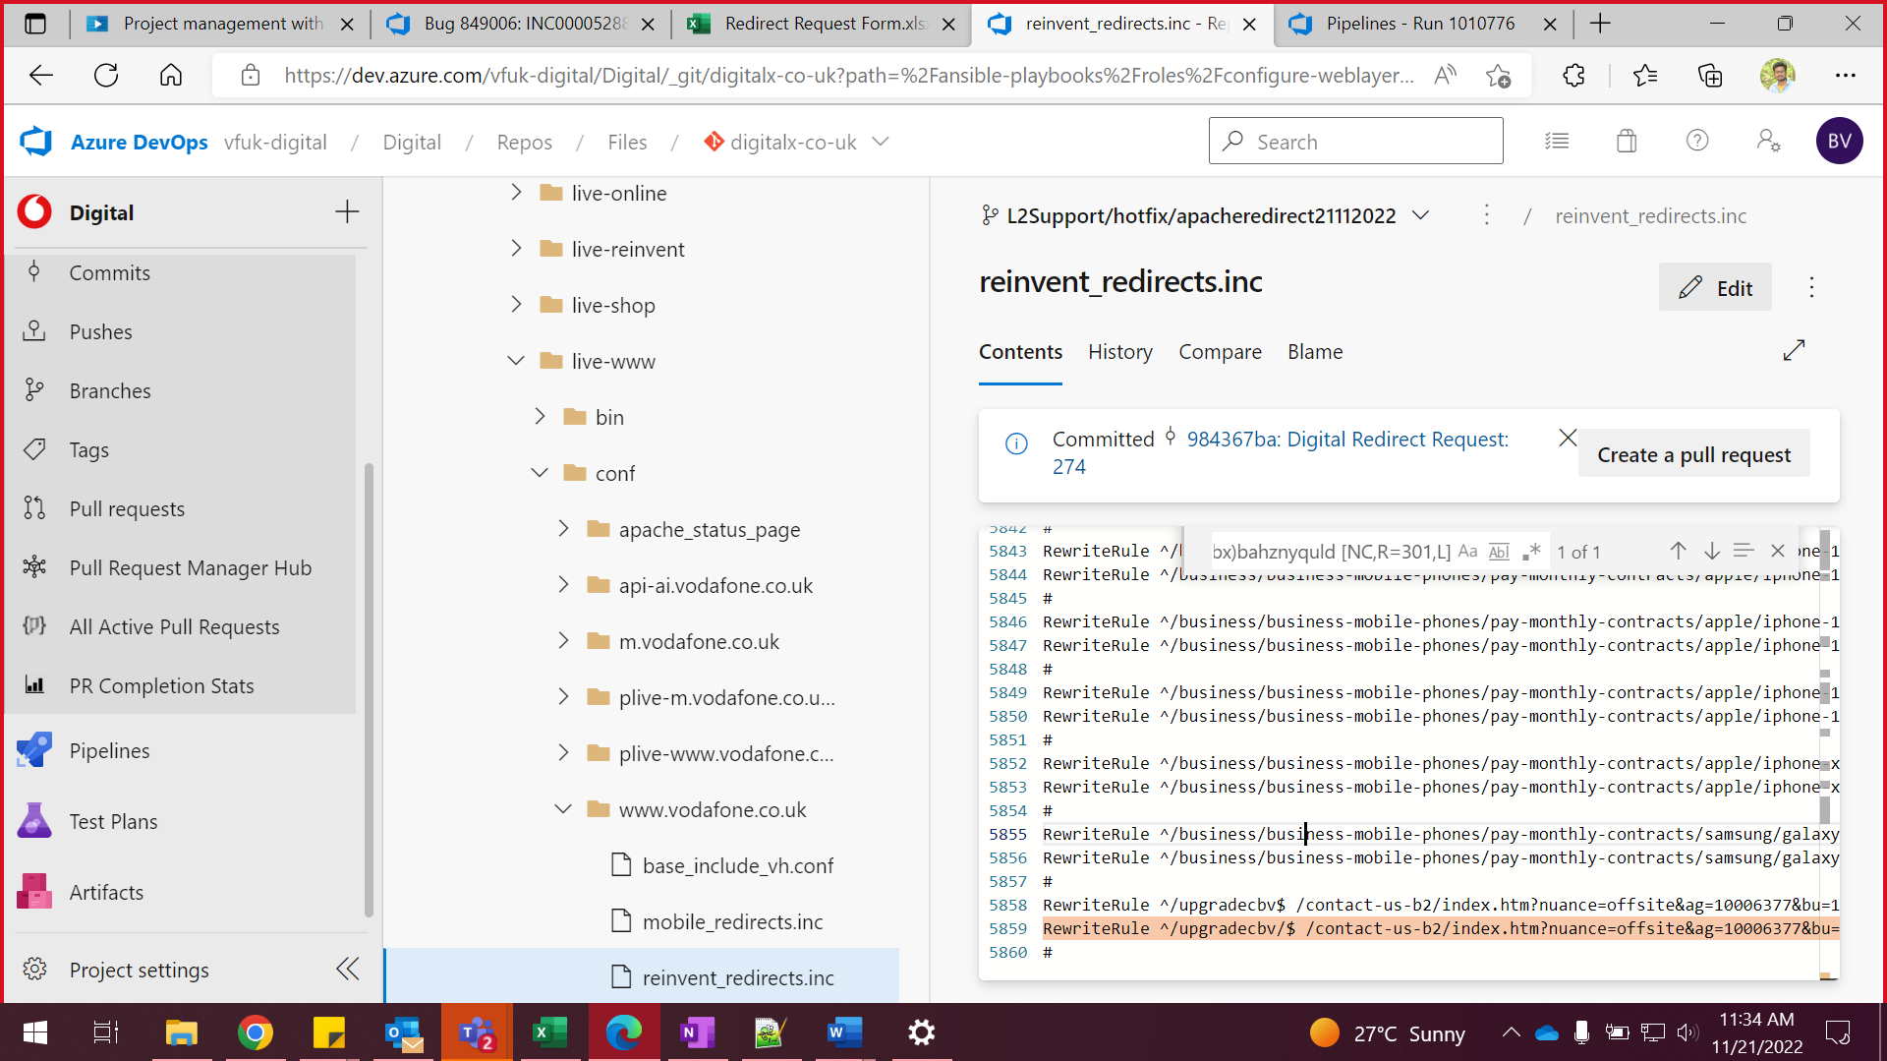

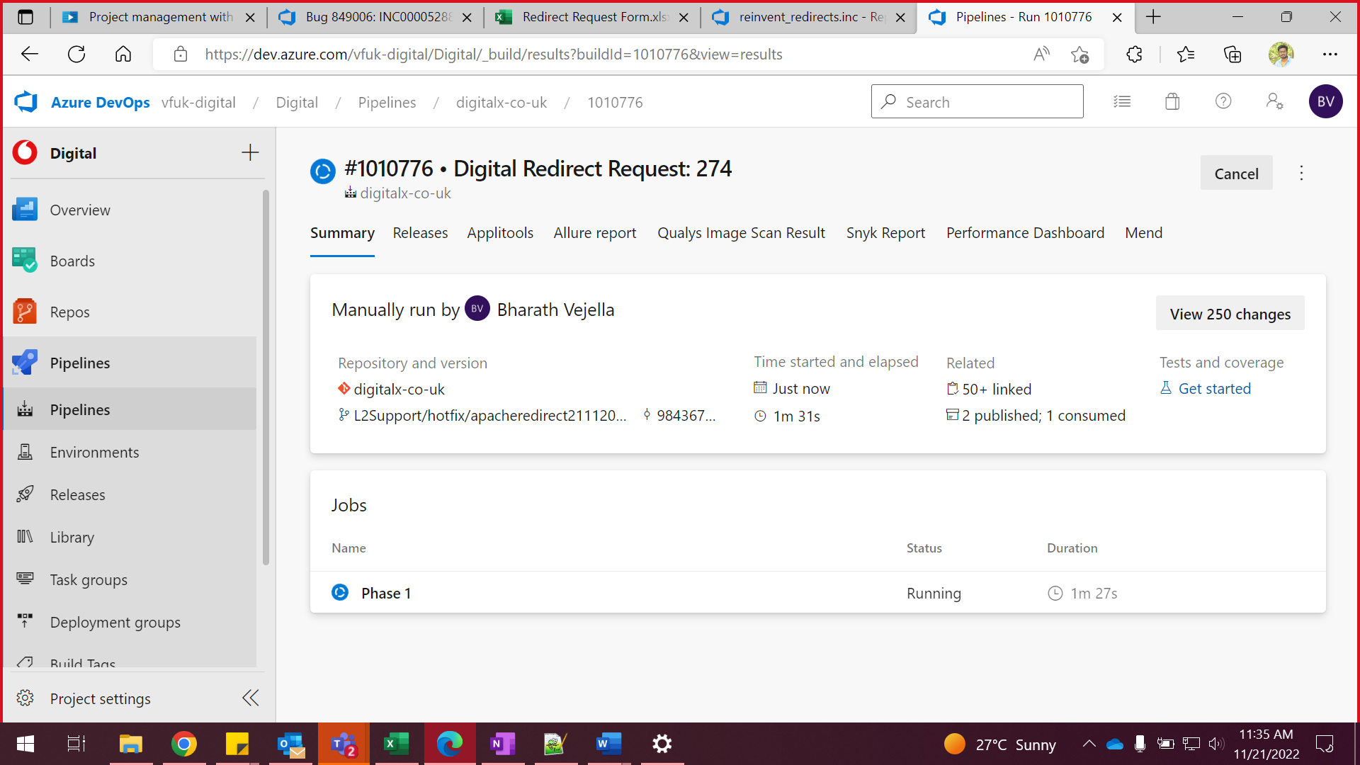

**#1010776 • Digital Redirect Request: 274**

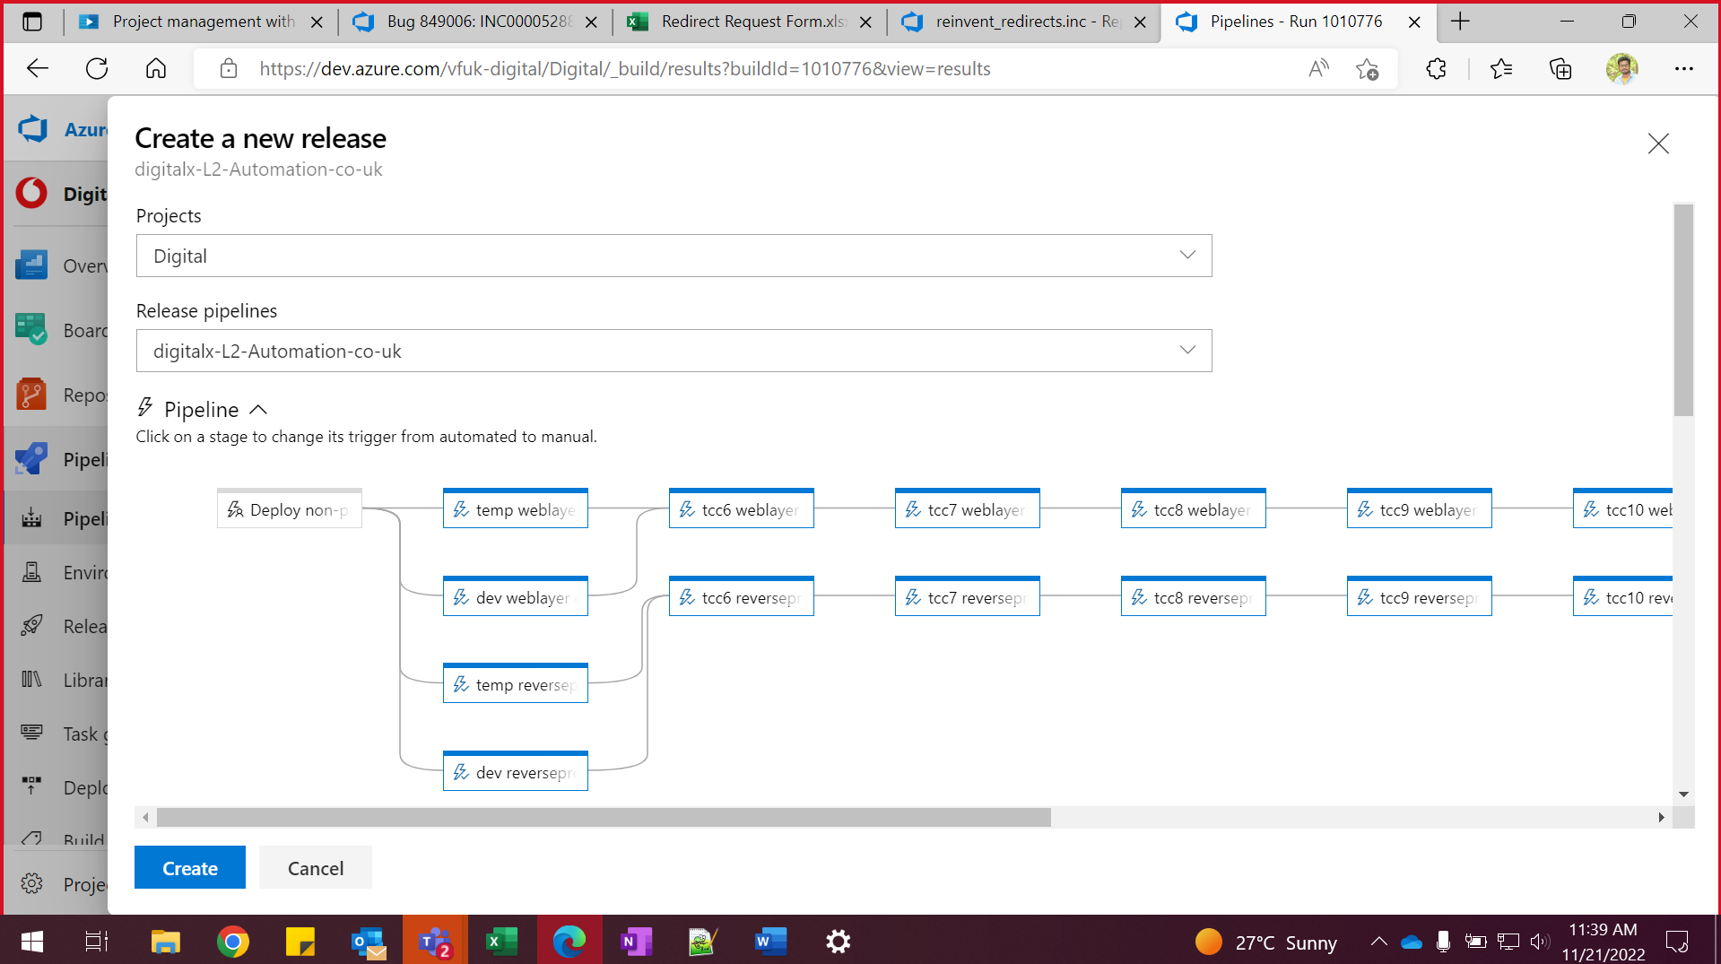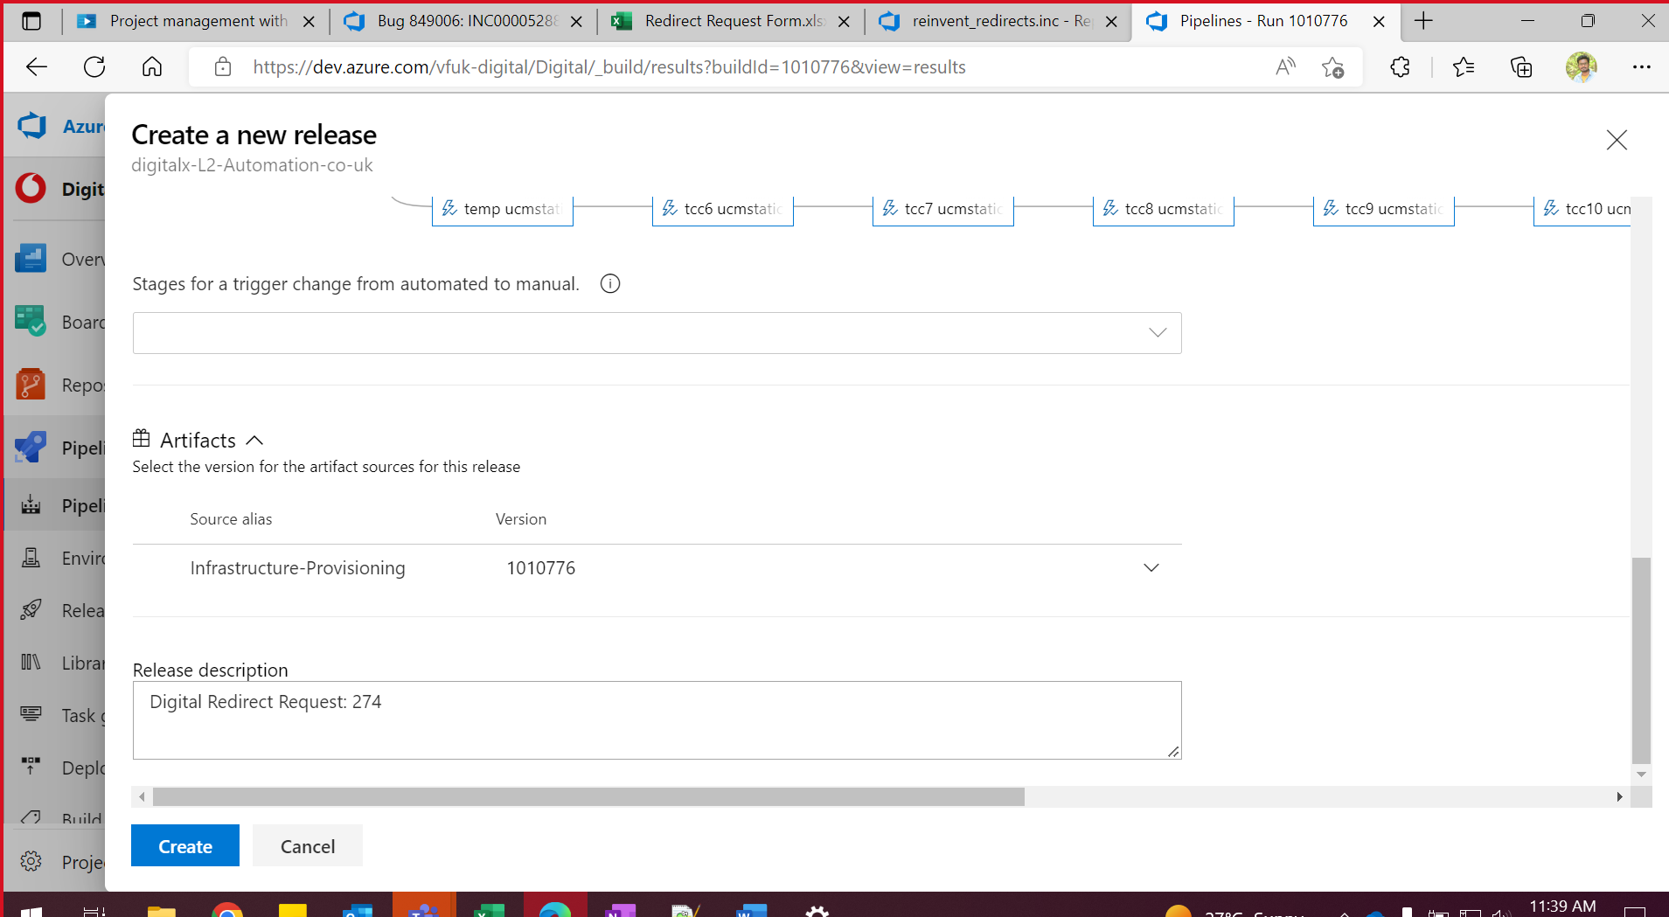

**#1011315 • Merged PR 148070: Merging L2Support/hotfix/apacheredirect21112022 i**

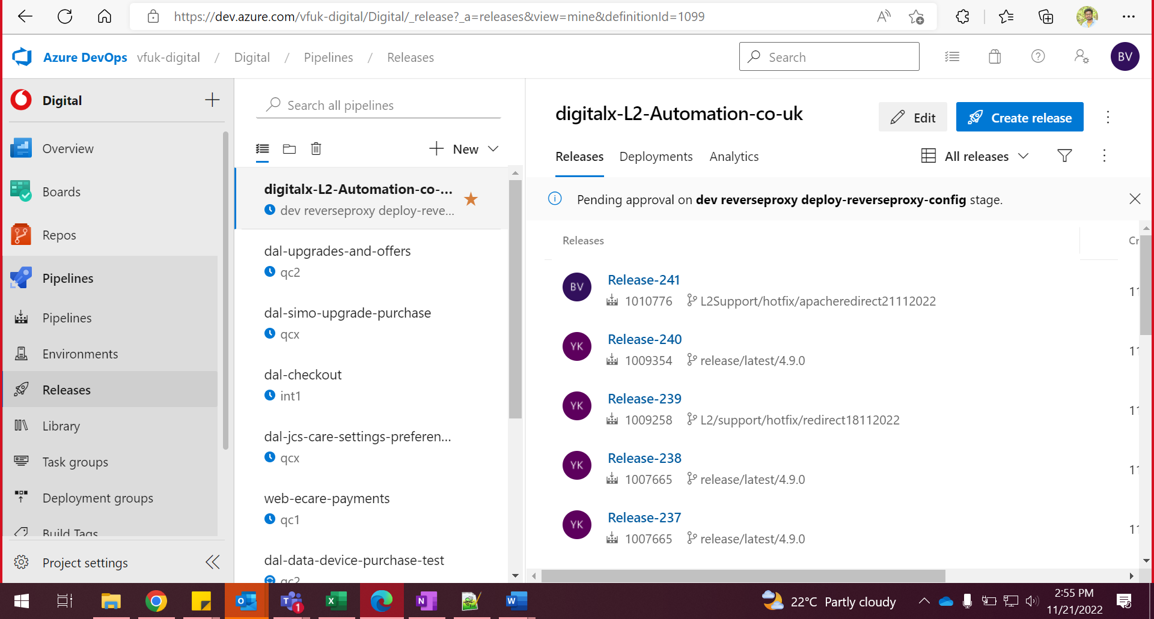

Create release

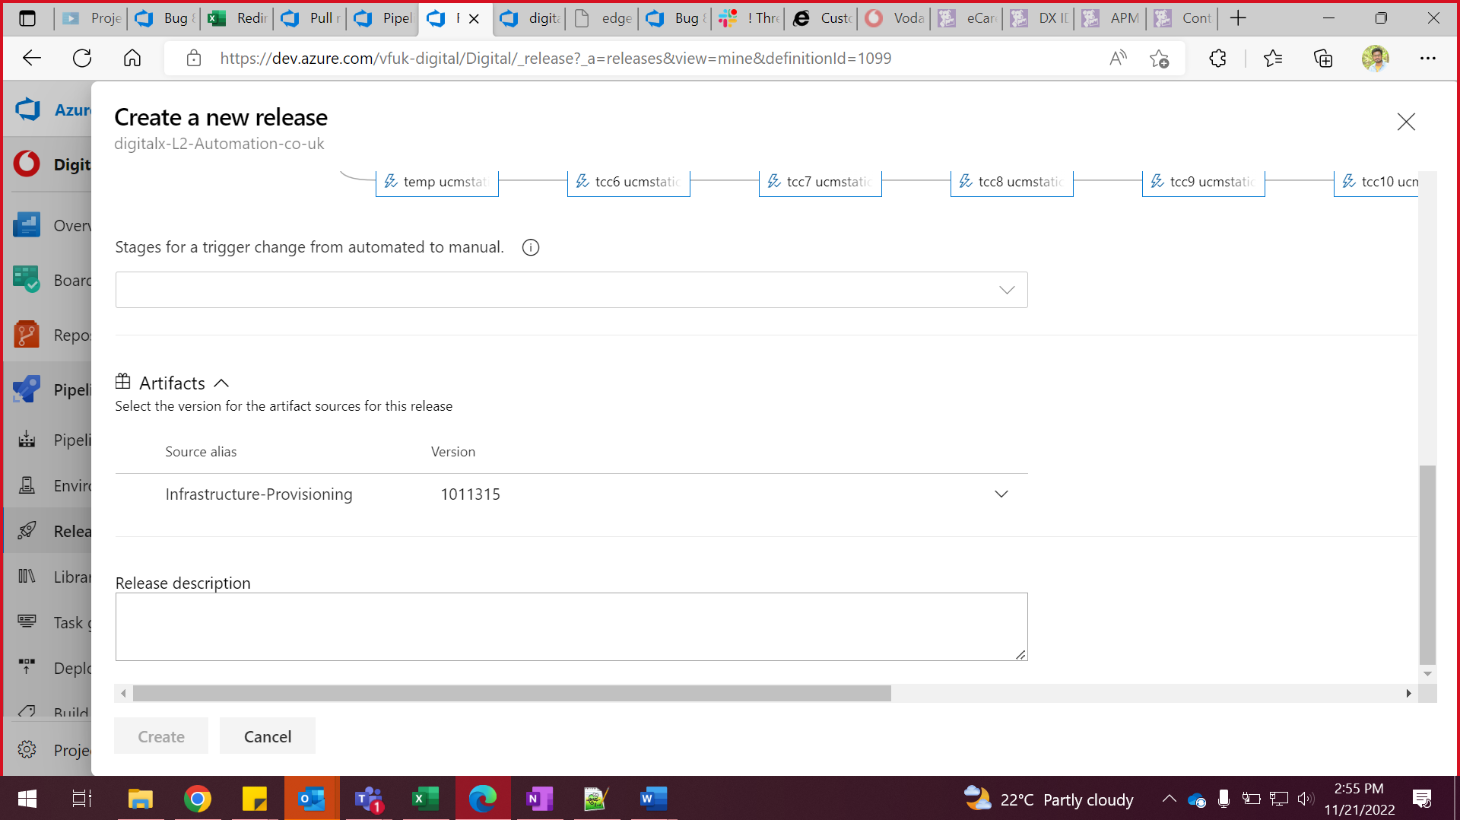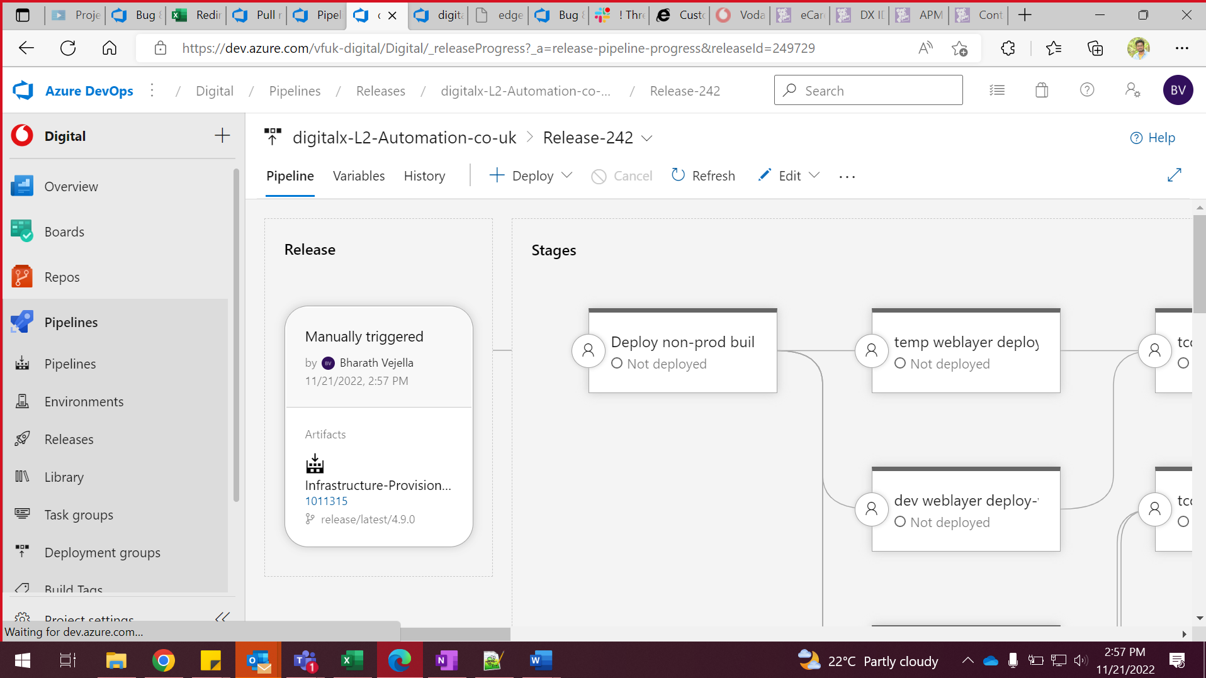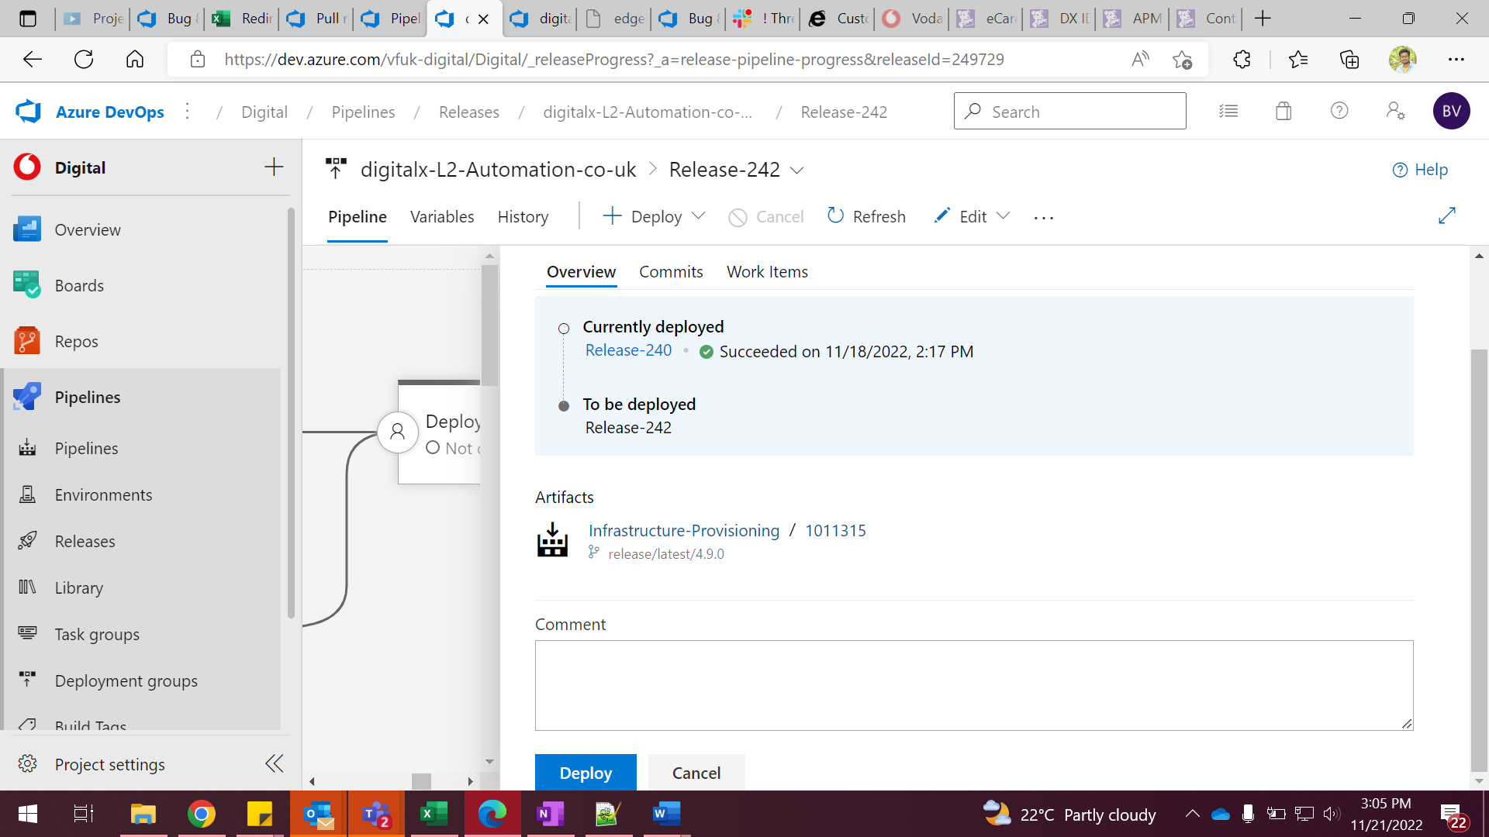

Cancel the reverseproxy